**Software installation**

Install the following packages before setting up WinFluor with a PCO Edge USB 3.0 camera.

1. National Instruments NIDAQmx device driver software for your NI interface unit.
2. PCO Edge Family USB 3.0 drivers
3. PCO SDK Installation
4. PCO Camware 64 bit.

**WinFluor Setup**

Start WinFluor and select **Setup > Camera/System Setup**

**Camera**

Select **PCO** **Cameras** as the Camera type.

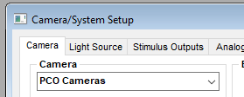

**Analog Inputs & Amplifiers**

Select **Device 1: AI0-15** as the Input Channels and the Input Mode as **Differential**.. If you are using a patch clamp, select the type of amplifier as Ampifier #1 and set the No. Channels In Use to **2**.

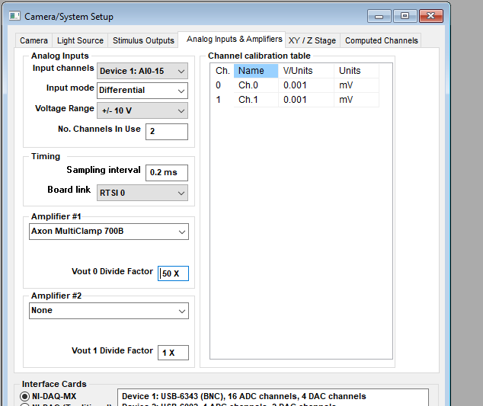

Connect a BNC cable between the **Primary** & **Secondary** output channels on the Multiclamp 700B patch clamp and **AI0** & **AI1** analogue inputs on the USB-6343-BNC.

**Stimulus Outputs**

Select **Device 1: AO0** as theVout 0 analogue output.

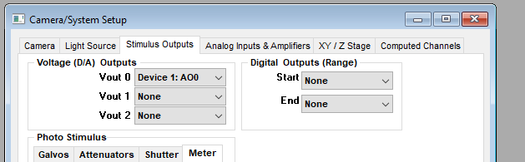

Connect a BNC cable between **AO0** on the USB-6343-BNC and the command voltage input of the patch clamp.

*Note. It is essential for timing purposes that at least one analog output channel is selected for use, even if a patch clamp is not in use.*

**Camera exposure trigger**

Select **Device 1:P0.0** as the Exposure Trigger Output.

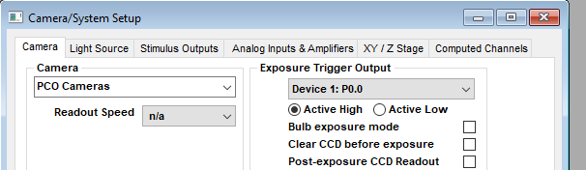

1. Connect a jumper wire between **P0.0** and **User 1** on the USB-6343 terminal block.
2. Connect an SMA – BNC shielded cable between **User 1** BNC socket on the USB-6343 and **In 1** on the PCO Edge 4.2 LT.

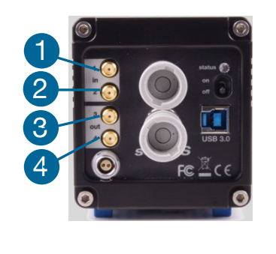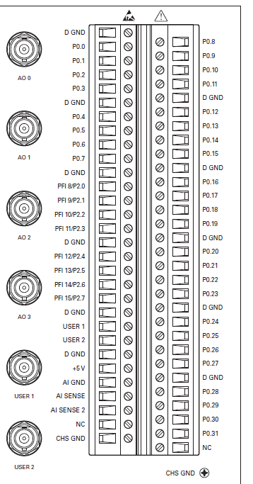

Note. A suitable 2 metre SMA – BNC cable can be obtained from  
 <https://www.digikey.com/en/products/detail/cinch-connectivity-solutions-johnson/415-0028-M2-0/6579655>

**Light Source: CoolLed pe-340**

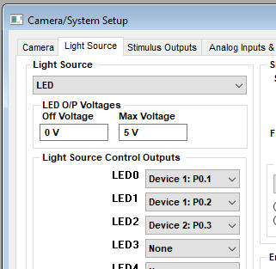Select **LED** as the Light Source type and select **Device 1:P0.1** to **Device 1:P0.3** as the outputs for LED0 to LED2.

Using shielded coaxial cables, connect:

|  |  |
| --- | --- |
| USB-6343-BNC | CoolLED pe-340 |
| P0.1 -> Signal DGND -> Ground | Channel 1 BNC |
| P0.2 -> Signal DGND -> Ground | Channel 2 BNC |
| P0.3 -> Signal DGND -> Ground | Channel 3 BNC |

